When using excel there are few things that can’t be viewed, as there will be some settings to change. It will be fine when dataset is opened in jupyter/spyder. Some screenshots are given below for reference.
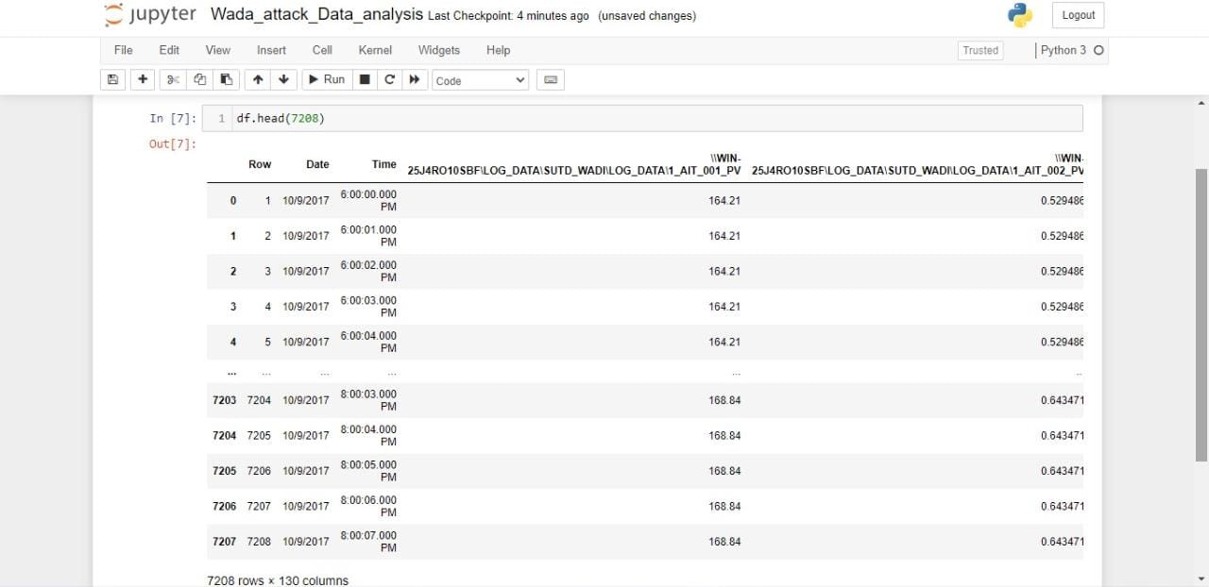
A small video is attached on how to change the settings in excel.

